 

**WORKSHEET – 2.4**

**Name:** Rahul Maurya

**Section/Group:** 716 B

**UID:** 20BCS7260

**Subject:** Computer Networks Lab

**Branch:** BE CSE (4th Semester)

**Aim:**

Create a network using Distance Vector routing Protocol using Packet Tracer

**Requirements:**

* Cisco Student Packet Tracer

**Algorithm/Flowchart (For programming-based labs):**

1. Open the simulator.
2. Plot some generic routers and some end devices(PC’s) where end devices to router is connected by Automatically Choosen wire and routers are connected each other by Serial DCE wire type.

**CHANDIGARH UNIVERSITY COMPUTER NETWORKS LAB**

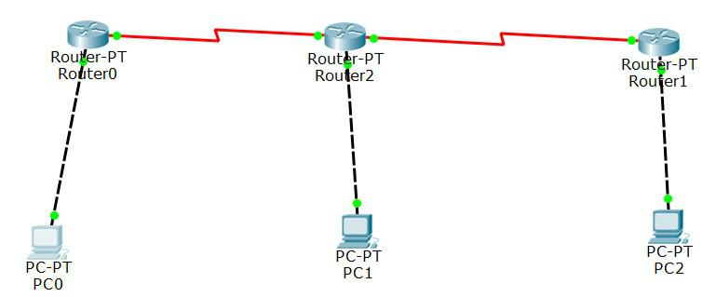**** 

1. Give Ip addresses to all the end devices and give default Ip address to router with default gateway.

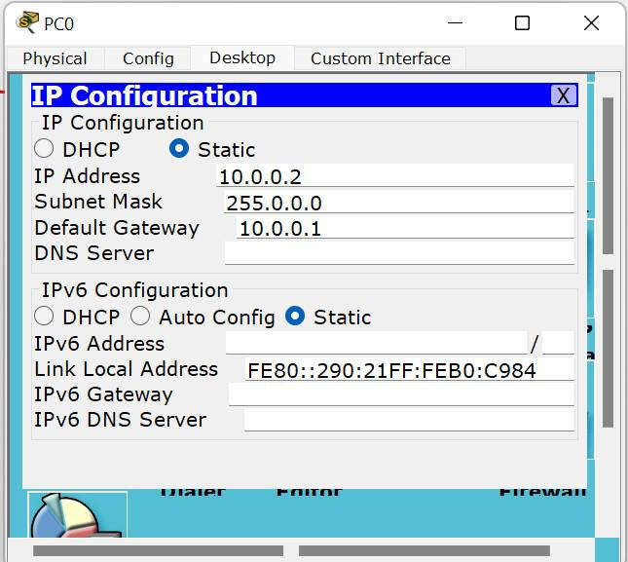

1. Now, Configure router’s fast ethernet with port status ON.

**CHANDIGARH UNIVERSITY COMPUTER NETWORKS LAB**

 

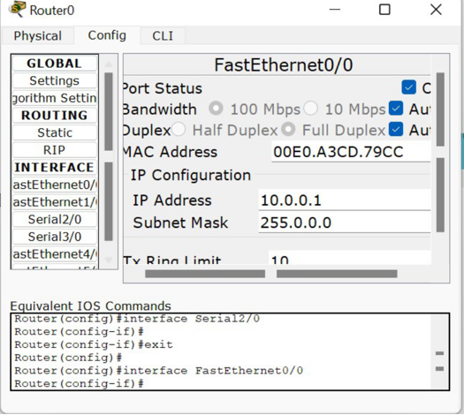

1. Now, configure router’s serial port with clock rate 64000 and port status ON.

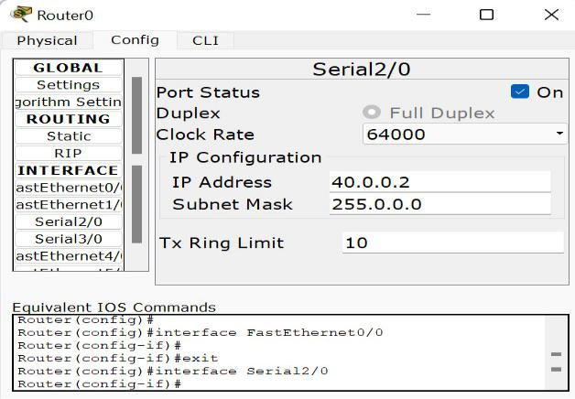

1. Now, configure static routing of router.

**CHANDIGARH UNIVERSITY COMPUTER NETWORKS LAB**

 

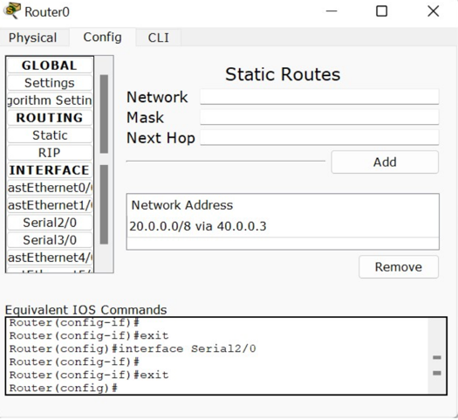

1. Also, now similarly setup other routers and end devices for perfect setup for experiment. And make sure all connections are green.

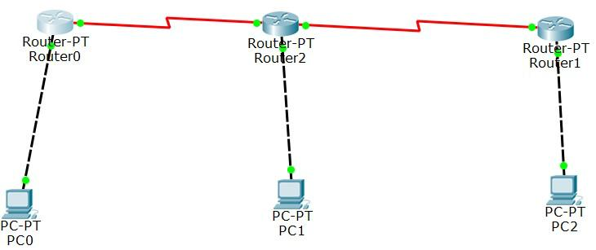

1. Now, run stimulation in real time by PDU.
2. Now, check successful status.

**CHANDIGARH UNIVERSITY COMPUTER NETWORKS LAB**

 

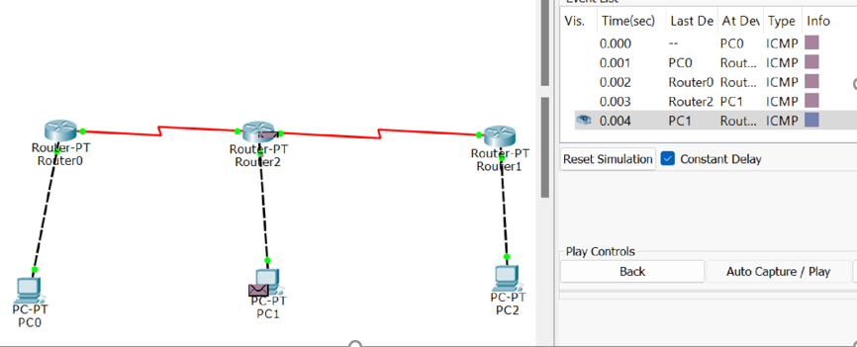

1. Now stop stimulation after successful output for experiment

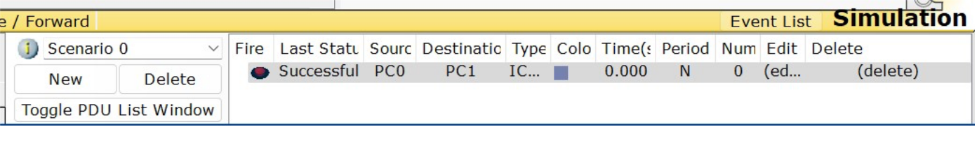

**Result/Output/Writing Summary:**

Understanded how packet travels in network if RIP is configured as routing protocol.

**CHANDIGARH UNIVERSITY COMPUTER NETWORKS LAB**

 

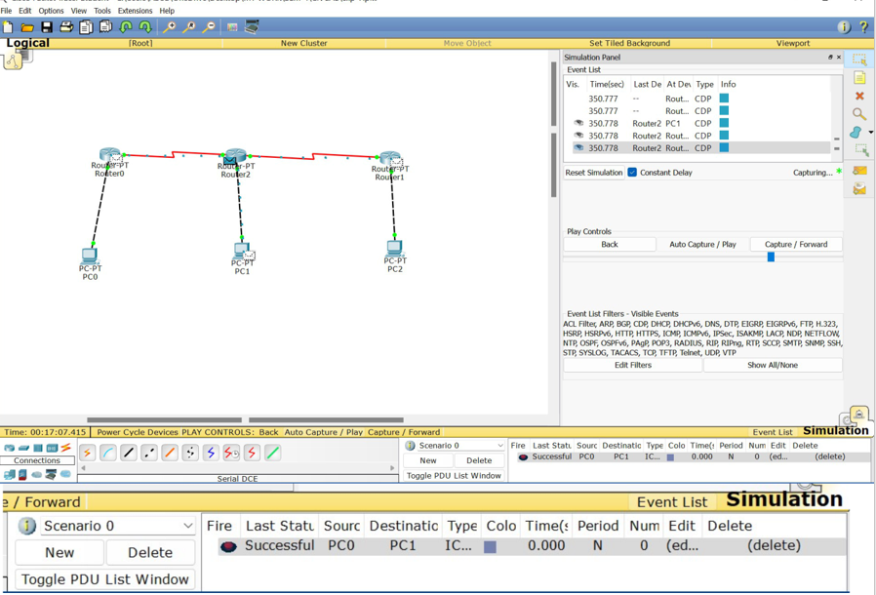

**Learning outcomes (What I have learnt):**

1. Know about how the data is transfer through computers.
2. Uses of switches(Can be used) and routers.
3. Knowledge abouts address like Ip, default, static routing, etc.
4. Some knowledge about port status, subnet mask.
5. We get to know about static and serial status.
6. We also know about clock frequency.

**CHANDIGARH UNIVERSITY COMPUTER NETWORKS LAB**